**Homework 1**Lesson: Mean and Variance AnalysisStudent Name: Zhao EnpingClass: G1

1. **Mean Return and Standard Deviation of 10 portfolio:**

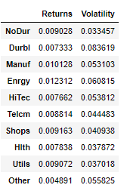

1. **Minimum Variance Frontier:**

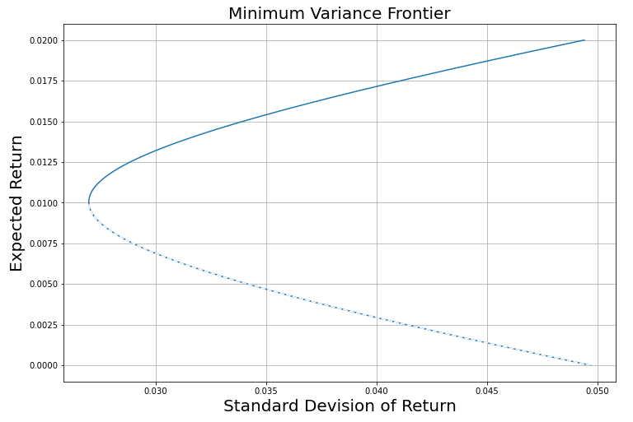

Significance to Investor:

The minimum variance frontier is the set of optimal portfolios (only include risky assets) that offer the highest expected return for a defined level of risk or the lowest risk for a given level of expected return. Portfolios that lie below the minimum variance frontier are sub-optimal because they do not provide enough return for the level of risk. Portfolios that cluster to the right of the minimum variance frontier are sub-optimal because they have a higher level of risk for the defined rate of return. Therefore, Investor should always invest in portfolio on the efficient frontier to maximize their return on investment.

1. **Efficient Frontier**

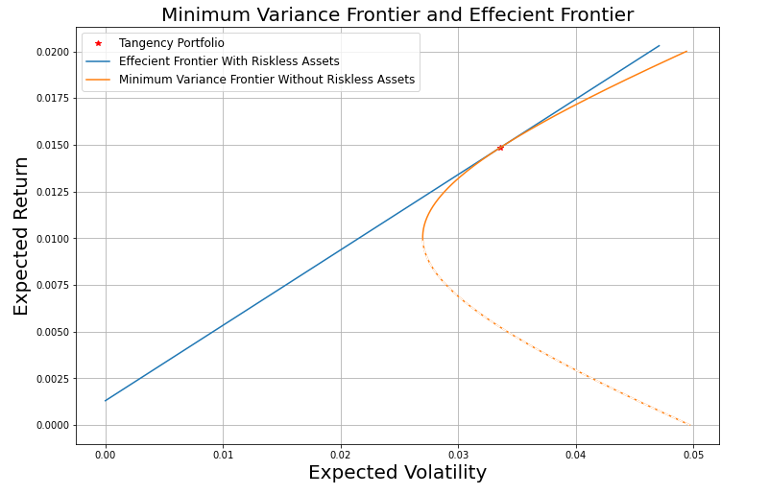

Significance to Investor:

The efficient frontier is the set of optimal portfolios (including riskless assets) that offer the highest expected return for a defined level of risk or the lowest risk for a given level of expected return. Portfolios that lie below the efficient frontier are sub-optimal because they do not provide enough return for the level of risk. Portfolios that cluster to the right of the efficient frontier are sub-optimal because they have a higher level of risk for the defined rate of return. Therefore, Investor should always invest in portfolio on the efficient frontier to maximize their return on investment.

1. **Tangency Portfolio:**

Sharp Ratio ≈ 0.4035655993495097

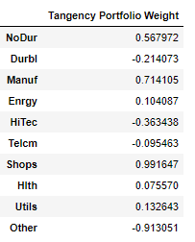

Significance to Investor:

Tangency Portfolio is the intercept point of Minimum Variance Frontier and Efficient Frontier, it has highest Sharpe Ratio out of all risky portfolios. investors seek to maximize their investment by having the highest sharp ratio through risky portfolio should always invest in Tangency Portfolio.

**Appendix:**

